Project Management Professional (PMP) Certification – SHORT LEARNING PROGRAMME
COURSE OVERVIEW
“Project Management Professional (PMP) Certification” offered by us is one of the most sought certifications in the fields of Project management. This certification promises the individual to acquire knowledge of various principles and process involved in managing a project effectively. Aspirants of project management should gain in depth understanding of the principles and its applications in various processes as defined in the book of knowledge (PMBOK). These principles and processes keep updating with time. The PMBOK is Version 6 to maintain pace with the changing Project Environment.
DURATION
12-18 Weeks Self-study programme. Examination upon completion of studies.
OBJECTIVES
On completion of this course, delegates will be able to:
- Successful completion of the PMP examination will show employers that you are an internationally recognised project manager.


- Clearly define what constitutes a project.
- Plan, organise and document a project in a logical manner.
- Use appropriate tools and documents in order to plan the project effectively and to minimise risk.
- Demonstrate knowledge of delegation, time management, decision making and communication skills essential to effective project implementation.
- Review and learn from strengths and weaknesses identified on completion of a project.
- Influence people and negotiate solutions to problems which arise during your projects.
LEARNING CONTENT
MODULE ONE
What is a Project?
- Defining what we mean by project management
- Special features of projects
- Understanding why projects fail
The Project Life Cycle
- Identify a four-stage approach to managing projects
- Understand the value of the project life cycle
- Preparing and outlining the project
Defining a Project
- How to clearly define a project
- Setting and agreeing objectives, scope and constraints
- Recognise the need to manage project stakeholders
- Define roles and responsibilities in a project
- Appreciate the importance of team working within the project
Project Planning
- Basic planning tools and techniques
- How to time and cost estimates more credible and realistic
- Establish a project communication strategy
- Simple risk management tools and techniques available to avoid surprises
- Creation of project documentation and data display methods
Implementing the Project
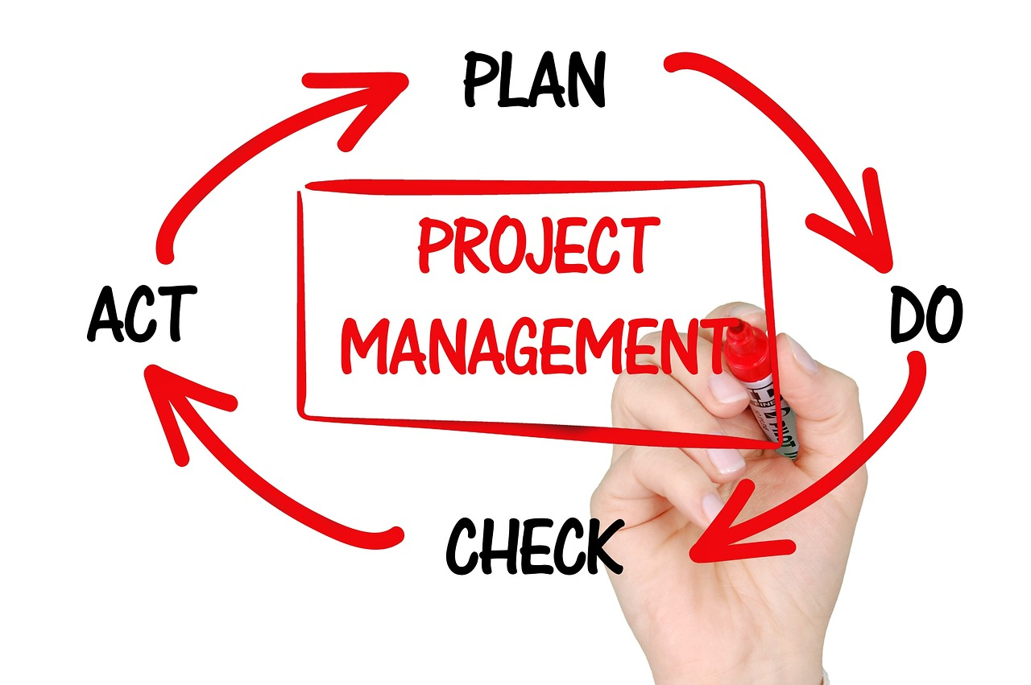
- Monitoring and controlling activities
- Taking corrective action to keep the project on track
- Dealing with requests for change
- Reporting progress
Closing and Reviewing a Project
- Understand the need for a controlled close to a project
- Measuring what actually happened against the plan
- Learning lessons - both positive and negative
- Closing down and moving on
* Additional module information will also cover the following –

- PMBOK 6
- PRINCE 2
- The Project Management Context
- Project Management Processes
- Project Integration Management
- Project Scope Management
- Project Time Management
- Project Cost Management
- Project Quality Management
- Project Human Resource Management
- Project Communications Management
- Project Risk Management
- Project Procurement Management
- Managing work as projects
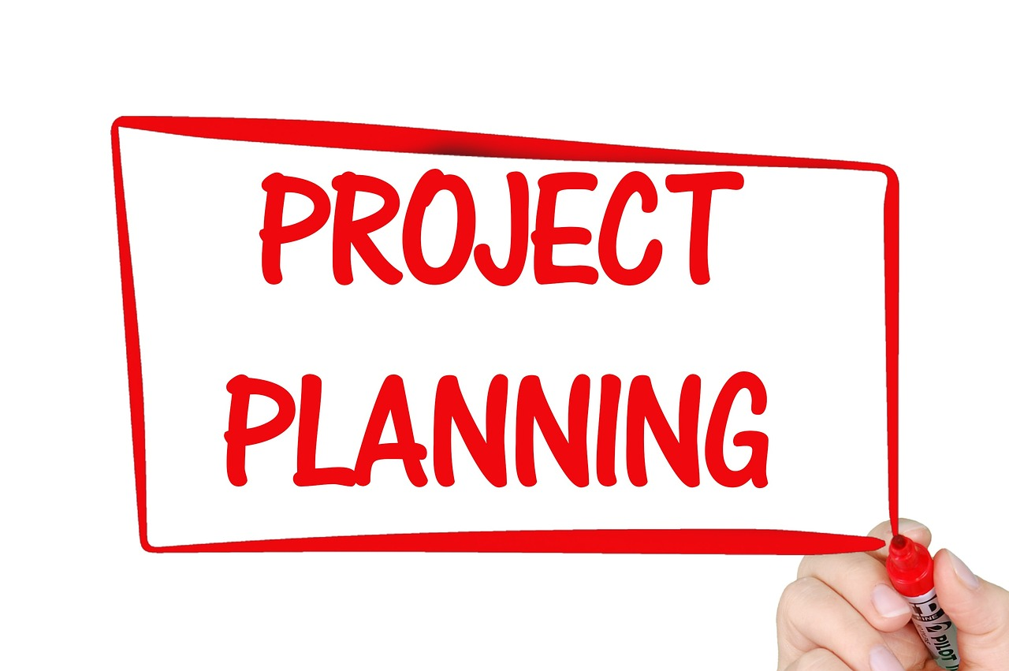
- The project environment
- Project & matrix management
- Management responsibilities
- Types of project management structure
- Identifying sources of conflict
- Project commissioning & ownership
- Defining the project life-cycle
- Project initiation
- Managing the life-cycle
- Role of the project manager
- Motivating the project team
- Creating an effective Project office
- Project closure

FEES / ENROLMENT OPTIONS

R1 890, 00 – includes learning material, examination and certification.
WE ARE NOW GOING GREEN: Easy and convenient: Course content will be sent to you via email.

Kindly note: There are no payment terms

ENROLMENT FOR THIS PROGRAMME

To enroll for this course, kindly e-mail Julie at info@sbdstudies.org

