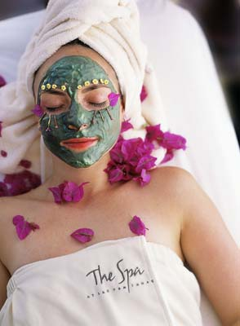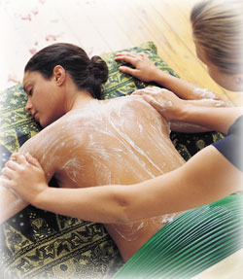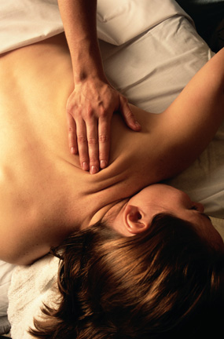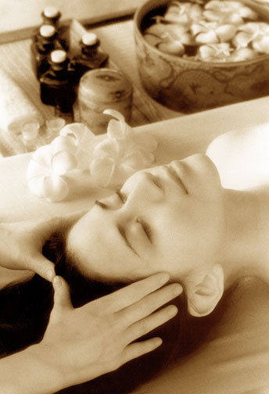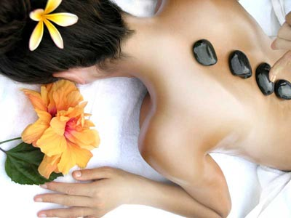

INVITATION - SECRETARY’S DAY CORPORATE WELLNESS PROGRAMME
An efficient Personal Assistant works closely with management, displays a strong sense of business etiquette and responsibility, takes initiative, corresponds professionally via all mediums, delegates tasks, manages crisis situations, co-ordinates events, shows confidence and is professionally dressed. The “SECRETARY’S DAY CORPORATE WELLNESS PROGRAMME “is the ideal conference for those needing to improve their administrative assistant skills or for those looking for the extra business edge as well as a nice way for an employer to say, “Thank you for being an awesome P.A and you’re getting training in a special way”.

LEARNING CONTENT
We will cover topics such as:
- Super Assistant: What the Boss Expects
- Minute taking Protocol and Professional Business Writing
- Styles and Different Kinds of Bosses
- Professional Presence: Looking and Acting the Part
- Difficult Personalities and Difficult Situations: Dealing with Challenges
- Time Management
- Conflict Management
- Stress Management
- Personal Branding
- Dynamic and Positive Body Language
- Self-Confidence

DURATION, DATE AND VENUE
This course is a 1 day programme which will be held at Mangwanani Day Spa, Hartbeespoort on Secretary’s Day, 6 September 2023 08h30 – 16h00.

PRICE/COST

This course is priced at R2 490, 00 per delegate: Includes Comprehensive training material, Certificate of completion, Breakfast, Lunch, Hand massage, Facial, Hot Rock massage, Foot massage, Indian head massage, Exfoliation, Session in the Jacuzzi or Pool and end this day with Decadent Chocolate and Liqueur.

ENROLMENT FOR THIS COURSE

To enrol for this course, kindly e-mail complete the enrolment form and email it to Julie at info@sbdstudies.org before Friday 1 September 2023

